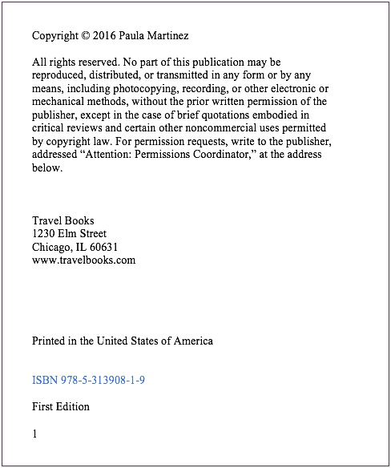

**Source is fictional**

City

Publisher

Year of publication